REPORT ON THE LEADERSHIP TRAINING PROGRAMME

ORGANISED BY

CHILD HEALTH, ENVIRONMENT AND SAFETY TRUST (CHEST)

HELD AT THE

ARORO KOLE COMMUNITY (RCCG KING'S NEW SONG KNS AREA HEADQUARTERS) ARORO KOLE, IBADAN, OYO STATE

THEME: INTERNET ADDICTION, POOR READING CULTURE AND DECLINING ACADEMIC PERFORMANCE

4TH MAY, 2025

EXECUTIVE SUMMARY
The increasing prevalence of internet addiction, poor reading culture, and declining academic performance among students presents a multifaceted challenge that impacts not only individual development but also the future intellectual capacity of society. As the digital world continues to expand, students are becoming more distracted, less focused on traditional learning methods, and more susceptible to academic underachievement. Addressing these issues through focused education and leadership training is essential to preparing young people to thrive in a knowledge-based society.
The leadership training programme organized by the Child Health Environment and Safety Trust (CHEST) was designed to communicate these pressing issues through an educational experience that inspires behavioral change and enhances academic development. The program sought to promote responsible internet use, encourage active reading, and improve academic outcomes by empowering students and parents with knowledge and actionable strategies.
A pre-survey was carried out among participants using a self-administered questionnaire to assess their understanding of internet addiction, reading habits, and academic challenges. Following the training. Training was conducted through expert-led teaching sessions on the theme “Internet Addiction, Poor Reading Culture and Declining Academic Performance”. These sessions included real-life examples, practical tips, and expert analysis of how digital distractions negatively influence academic success. A documentary on internet addiction further reinforced these lessons.
The program also featured an interactive question-and-answer session, where participants engaged directly with facilitators to deepen their understanding. Additionally, to promote a lasting reading culture, an educational textbook was donated to the community library.
We believe that education is a powerful tool to shape responsible, high-performing future leaders. Children must be guided to balance internet use with disciplined academic habits and meaningful reading experiences. At CHEST, we are committed to developing 1000 youth leaders this year, and we believe this leadership training programme is a vital step toward achieving that vision.

INTRODUCTION
Child Health Environment and Safety Trust carried out her first programme for the year, the leadership training programme tagged “Internet Addiction, Poor Reading Culture and Declining Academic Performance”.
This event took place on Sunday, 4th May, 2025 in the Church Auditorium at the RCCG King's New Song (KNS) Area Headquarters, Aroro Kole, Ibadan, Oyo State. The program had a survey and teaching sessions. There were participants from different areas in Aroro Kole community, parents and CHEST officials. The event was for a duration of 2 hours 15 minutes from 11:45am-2:00pm.
The aim of the training program was to educate young individuals and parents on the effects of internet addiction, promote a culture of active reading, and provide strategies to improve academic performance among students. Its specific objectives were to:
- raise awareness about the negative impact of excessive internet use on students’ academic focus and outcomes.
- promote positive reading habits by encouraging the use of printed books and reducing digital distractions.
- educate participants on the root causes of declining academic performance and practical ways to overcome them.
- empower parents and guardians with tools to guide and monitor children’s internet use effectively.
- foster community engagement in supporting students’ educational development through resource donations and sustained follow-up actions.

HIGHLIGHTS OF THE EVENT
The program started at 11:45 am with Professor G.R.E.E. Ana gave an address welcoming all participants and introducing them to Child Health Environment and Safety Trust, the officials and activities of the organisation.
The training session started with a presentation on the topic “Internet Addiction, Poor Reading Culture and Declining Academic Performance” delivered by Prof., G.R.E.E. Ana. He explained that Internet addiction negatively impacts reading culture by diverting time and attention from reading towards online activities like social media, gaming and browsing which could lead to decreased reading habits, reduced comprehension skills, and potentially lower academic performance.
He also stated that Internet addiction has a detrimental impact on academic performance, often leading to reduced study time, difficulties in completing assignments and ultimately lower grades and emphasized that students who are addicted to the internet may neglect their studies, prioritize online activities, and struggle with time management, all of which contribute to academic decline.
Mrs Onijala encouraged the participants to reduce the time spent on the internet and improve their reading culture especially reading hard cover books. She cited practical examples and the detrimental effects in each case.
Mr Kolasanusi spoke on the declining academic performance in schools, stating the different causes of this emerging trend. He enlightened the participants on the importance of getting excellent grades in their respective classes. He taught the participants how to improve their academic performances.
The managing director, Dr (Mrs) Magaret Ana spoke on the negative ways improper use of the internet has destroyed the lives of children both academically and otherwise. She emphasized that parents and the participants themselves should enforce discipline when using the internet daily
A documentary showcasing the internet addition was shown to further instil the knowledge being passed.
The question and answer session was facilitated by Professor G.R.E.E. Ana. In order encourage a good reading culture, a textbook on environmental health was donated to the Library. The vote of thanks was given by the President, Professor G.R.E.E. Ana. The closing prayer was said and the programme came to an end by 2:00 pm with group photograph.
APPROACH ADOPTED FOR THE PROGRAMME
The following strategies were employed to achieve the objectives of the programme:
- Survey: A survey were carried out among the participants via self-administration questionnaire method to ascertain the impact of the training on their knowledge level on the concept of Internet Addiction, Poor Reading Culture and Declining Academic Performance
- Training: Training was carried out via a presentation of lectures on “Internet Addiction, Poor Reading Culture and Declining Academic Performance”. This was followed by documentary showcasing the Effects of Internet Addiction.

CONCLUSION
We believe that education can be used to raise the change makers needed to solve the problems plaguing our planet, society and the economy and it is only right that children should imbibe an excellent reading culture and reduce the time spent on the internet. Striking a healthy balance ensures an improved academic performance which in turn produces excellent leaders across all spheres of life. At CHEST, we are committed to developing 1000 leaders in our community this year and we believe that this leadership program is a strategic part of that journey.

APPENDICES
Attendance

PARTICIPANTS | No.
CHEST Officials | 6
Parents | 14
Participants | 34
TOTAL | 54

Survey Findings
Social-demographics characteristics
The socio-demographic characteristics of the participants are presented in Table 1 below. The findings from this survey showed that the age of the participants ranged between 9 – 25 years. 68% of the program participants were male and 32%, female. 100% of the participants practice Christianity. 54% of the participants had secondary school education with 9% having primary school education and 4% having tertiary school education Majority (75%) while few others are Hausa, Igbo, Igbera and Efik.

Table 1: Socio-demographic characteristics of respondents
Variable | Frequency | Percentage (%)
Age (years)  9-14  15-20  20- 25 | 16  11  1 | 57  39  4
Sex  Male  Female | 19  9 | 68  32
Religion  Christianity | 28 | 100
Level of Education  Primary  Secondary  Tertiary | 9  15  4 | 32  54  14
Ethnicity  Yoruba  Hausa  Igbo  Others | 21  1  1  5 | 75  3  3  19

Internet Use among Participants
The majority of respondents (61%) reported no access to a smartphone or tablet while 39% indicated access. In terms of non-academic internet use 46% spent less than one hour daily online, with 27% each spending 1–2 hours and 3–4 hours. None reported usage of five hours or more.
Internet use was primarily for studying (50%) followed by social media (18%). An additional 8% each reported usage for watching videos, studying combined with social media or a combination of studying, social media and gaming.
Internet addiction was most commonly identified as feelings of anxiety or restlessness without access (72%). Equal proportions (14%) associated it with usage during school hours or for homework. A significant 96% identified reduced academic focus as a major consequence while only 4% cited improved reading speed.
The most recognized indicator of addiction was an inability to concentrate in class due to screen distraction (78%). Other signs included comfort without devices (11%), taking regular breaks (7%) and preferring group discussions over browsing (4%).
Responsible internet use was most widely defined as visiting educational websites with scheduled time limits (96%) with only 4% viewing entertainment during study as appropriate.
The need for boundaries in internet use was emphasized by 86%, who linked it to avoiding distractions like messaging during class. Only 7% associated boundary-setting with gaming or academic research.
All respondents (100%) agreed that researching school topics and accessing online libraries is the most effective academic use of technology. Internet use was considered problematic by 86% when it replaced studying, reading, or sleep. Only 11% and 3% viewed its use for assignments or in-class activities as concerning.

Table 2: Internet Use among Participants
Variable | Frequency | Percentage (%)
Do you have access to a smartphone or tablet?  Yes  No | 11  17 | 39  61
How many hours per day do you spend inline (outside school work)?  Less than 1 hour  1-2 hours  3-4 hours  5 hours or more | 5  3  3  0 | 46  27  27  0
What do you mostly use the internet for?  Studying  Social Media  Watching videos  Studying and social media  Studying, social media and playing games | 6  2  1  1  1 | 50  18  8  8  8
Which of the following best describes internet addiction?  Using the internet only during school hours  Feeling anxious or restless without internet access  Using the internet for homework | 4  20  4 | 14  72  14
A major danger of Internet addiction is?  Reduced attention to academic responsibilities  Becoming a faster reader | 27  1 | 96  4
Which of the following is a sign that a student may be addicted to the internet?  Prefers group discussion to browsing  Feels comfortable without a device  Cannot concentrate in a class due to screen distraction  Takes regular breaks from technology | 1  3  22  2 | 4  11  78  7
What is a responsible way to use the internet  Using educational websites with scheduled limits  Watching comedy during study time | 27  1 | 96  4
Why is it important to set boundaries for internet use?  Playing games for stress relief  Researching school topics and accessing online libraries  Using messaging app during class | 2  2  24 | 7  7  86
What is the best way to use technology for academic growth  Researching school topics and accessing online libraries | 28 | 100
When does internet use become a problem for students?  When it is used for school assignment  When it replaces studying, reading or sleeping  When it is part of class activities | 3  24  1 | 11  86  3

Reading Culture of the Participants
A significant majority of respondents (89%) reported having a good reading culture, while 11% indicated they did not. Reading novels, essays, and academic texts was identified by 94% of participants as the most effective way to improve vocabulary and critical thinking. Only 3% each selected text messaging or following social media trends as beneficial.
To revive a declining reading culture, 89% of students favored organizing reading competitions and clubs. Smaller proportions supported increasing screen time (4%) or reducing literature classes (7%).
In terms of reading frequency beyond academic requirements, 43% of respondents reported reading daily, 14% weekly, 36% rarely, and 7% never. Dependence on internet searches for academic work was relatively low with only 14% indicating sole reliance compared to 86% who did not.
Lack of interest and digital distractions were cited by 75% of participants as the primary causes of poor reading culture among youth while 25% pointed to book fairs and exhibitions as positive influences.

Table 3: Reading Culture of the Participants
Variable | Frequency | Percentage (%)
Do you have a good reading culture?  Yes  No | 25  3 | 89  11
Which of the following best improves vocabulary and critical thinking?  Text messaging friends  Reading novels, essays and academic texts  Following trends on social media | 1  26  1 | 3  94  3
What do you think is one way to revive a declining reading culture?  Increasing screen time  Reducing literature classes  Organizing reading competitions and clubs | 1  2  24 | 4  7  89
How often do you read books unrelated to school?  Daily  Weekly  Rarely  Never | 12  4  10  2 | 43  14  36  7
Do you depends solely on internet searches to your academics work?  Yes  No | 4  24 | 14  86
One of the main causes of proper reading culture among youth is?  Lack of interest and digital distraction  Book fairs and exhibitions | 21  7 | 75  25

Perception of Declining Academic Performances among the Participants
The majority of respondents (86%) defined declining academic performance as a consistent drop in grades and loss of interest in learning. A smaller percentage identified increasing test scores (11%) or reduced classroom participation (3%) as indicators.
All participants (100%) agreed that poor time management negatively affects academic performance by leading to unfinished work and cramming. Similarly, 100% indicated that creating and following a study schedule is the habit most likely to support academic success.
Regarding the impact of late-night device use, 71% strongly agreed that it can lead to reduced concentration and memory. An additional 17% agreed while the remaining 12% were either neutral or disagreed.
Regular study was viewed by 86% of respondents as important for building consistency and deeper understanding. Only 7% each believed it either keeps students offline or replaces classroom teaching.

Table 4: Perception of Declining Academic Performances among the Participants
Variable | Frequency | Percentage (%)
Which of the following best defines declining academic?  Increasing test scores  Reduced classroom participation  Consistent drop in grades and learning interest | 3  1  24 | 11  3  86
How does poor time management affect academic performance?  It leads to unfinished work and cramming | 28 | 100
What habit is most likely to support academic success?  Creating and following a study schedule | 28 | 100
Do you believe that a students who sleeps late using devices may struggle concentration and memory?  Strongly Agree  Agree  Neutral  Disagree  Strongly Disagree | 20  5  1  1  1 | 71  17  4  4  4
Why is regular study important for students?  It builds consistency and deeper understanding  It keeps students offline  It replaces classroom teaching | 24  2  2 | 86  7  7

General Perception of the Participants on Internet Use, Reading Culture Declining Academic Performances
Table 5 shows the participant’s perceptions of how internet use impacts their reading habits and academic performance, and to explore strategies for maintaining a healthy academic lifestyle.
The majority of respondents (75%) believed that students can best balance internet use and academics by setting limits and prioritizing schoolwork. Meanwhile, 21% suggested avoiding the internet entirely, and only 4% supported unrestricted weekend use.
Finishing homework before screen time was identified by 94% of participants as the activity that best reflects strong study habits. Watching TV before studying and skipping reading sessions were each selected by only 3% of respondents.
A significant 91% indicated that increased screen time at the expense of reading leads to decreased academic performance. Only 3% each believed it results in improved focus, stronger memory or better sleep habits.
Monitoring screen habits was viewed by 82% of participants as essential to ensuring productive use of time. A smaller percentage associated screen monitoring with reducing reading time (11%) or staying online longer (7%).
In terms of optimal timing for educational internet use, 96% favored browsing after completing academic tasks. Only 4% considered late-night internet use before sleep appropriate.
Regarding early reading habits, 82% emphasized their importance for building a foundation in critical thinking and academic success. A minority cited avoiding lifelong internet use (7%) or impressing teachers (11%) as motivations.

Table 5: General Perception of the Participants on Internet Use, Reading Culture Declining Academic Performances
Variable | Frequency | Percentage (%)
How can students strike a balance between internet use and academics?”  Use the internet all weekend  Set limits and prioritize school work  Avoid the internet completely | 1  21  6 | 4  75  21
Which activity best reflects strong study habits?  Finishing homework before screen time  Watching TV before studying  Skipping reading session | 26  1  1 | 94  3  3
What happens when reading is ignored and screen time increases?  Improved focus in class  Stronger memory  Decreased academic performance  Better sleep habits | 1  1  25  1 | 3  3  91  3
Why should students monitor their screen habits?  To stay online longer  To reduce time for reading  To ensure time is used productively | 2  3  23 | 7  11  82
When do you think is the best time to browse the internet for learning?  After finishing academic tasks  Late at night before sleep | 27  1 | 96  4
Why is it important to build strong reading habits early?  To avoid using the internet forever  To impress teachers  To form a foundation for critical thinking and academic success | 2  3  23 | 7  11  82

Publicity

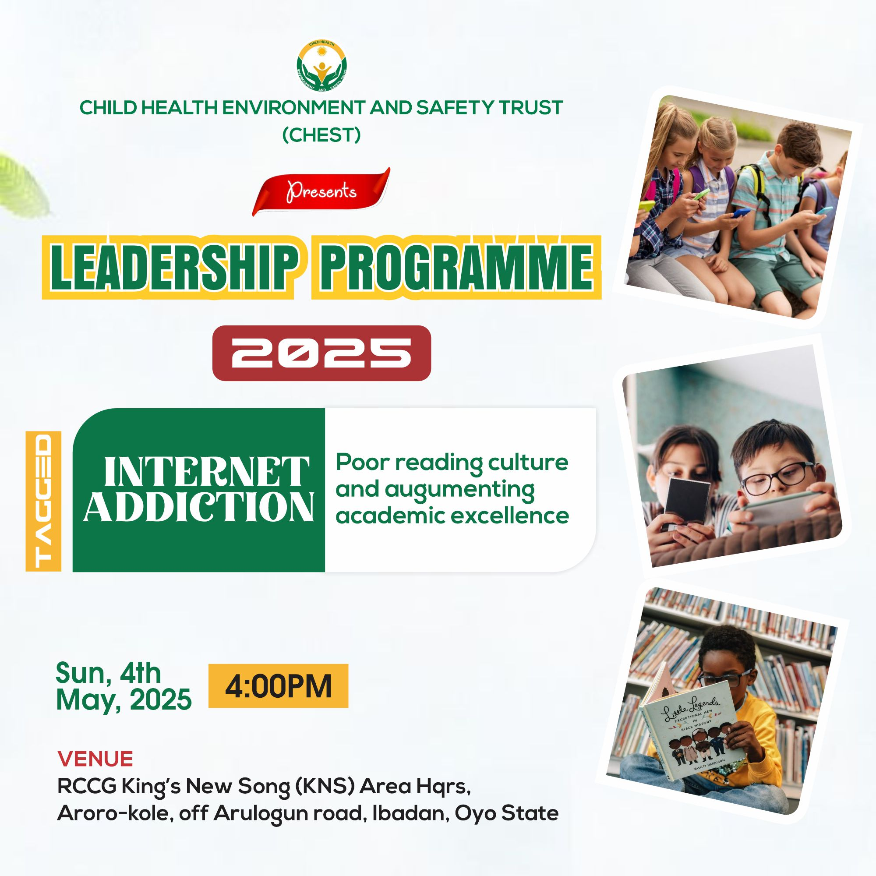 Programme E-flier

Expenditure for the Programme
ITEM | COST
Refreshment | ₦20,000
Fuel | ₦10,000
TOTAL | ₦30,000

PICTURE GALLERY

