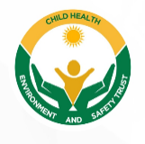
CHILD HEALTH ENVIRONMENT AND SAFETY TRUST

Program Theme: Contaminated Water and Health Risks: Combating Cholera amongst children
Cholera, caused by the bacterium Vibrio cholerae, is a significant health issue in Nigeria, especially affecting children under five due to their weaker immune systems, malnutrition, and limited access to clean water and sanitation. In Ibadan, rapid urbanization and inadequate infrastructure create conditions conducive to cholera outbreaks, particularly in low-income communities with poor access to clean water and functional sanitation. Cholera spreads through contaminated water and food, and environmental factors like seasonal floods worsen the situation by contaminating water sources. The disease causes severe dehydration and malnutrition, and if untreated, can lead to death within hours.
The lack of community awareness, limited access to clean water, and the absence of widespread vaccination programs exacerbate the problem. Effective solutions require a focus on water, sanitation, and hygiene (WASH) education, improved sanitation, and maternal training to help reduce cholera’s impact on vulnerable children. Hence the aim of this program was to increase awareness and practices that will contribute to reducing cholera incidence amongst community members especially children.
The program took place on 22nd of November, 2024, at Sasa market in Ibadan, Oyo state with specific objectives which were to:
- Identify the risk factors contributing to possible cholera transmission in the community.
- Assess knowledge, attitude and practices associated with sources of cholera transmission among participants.
- Evaluate current practices employed for cholera transmission control in selected study location.
- Educate and train community members on different approaches that promote sustainable hygiene practices and improve health knowledge.
Target population:
- The target population for this program are households with pregnant women and mothers of under 5 children.
APPROACH ADOPTED FOR THE PROGRAMME
The following strategies were employed to achieve the objectives of the programme:
- Community entry: This was done by approaching and meeting with the market leader and relevant stakeholders.
- Surveillance: This was carried out through an interviewer administered questionnaire method where socio-demographic characteristics of participants, knowledge, attitude and practices associated with contaminated water and health risks among participants were assessed.
- Training: A sensitization was carried out by Prof. G.R.E.E Ana during the advocacy session.

HIGHLIGHTS OF THE EVENT
The sensitization session of the program took place in the middle of the market square, starting around 11:00am with the executives of the organization introduces themselves to the market people. Prof G.R.E.E Ana gave a brief profile of the organisation, focusing on its vision, mission and its work activities.
The training session was officially initiated with Professor G.R.E.E. Ana taking the stage to address a group of local market vendors. His message, which focused on crucial public health issues, was delivered in a thoughtful and detailed manner, ensuring that all participants would leave with a deeper understanding of the material. In order to bridge any communication barriers, Miss Marvellous Oyediran was present to interpret Prof. Ana’s speech into Yoruba, ensuring that the entire audience, regardless of their primary language, was able to fully comprehend the content being discussed.
Prof. Ana began by emphasizing the severe health risks associated with contaminated water, a problem that is widespread in many areas, particularly in regions where access to clean water is limited or inconsistent. He explained how harmful pathogens found in polluted water can lead to a wide range of diseases, including diarrhea, cholera, and typhoid fever, which have devastating effects on public health. He made it clear that the consequences of these illnesses often go beyond the individual, as they can contribute to significant loss of productivity in communities and even overwhelm local healthcare systems.
To mitigate these risks, Prof. Ana underscored the importance of practicing proper hygiene. He pointed out that something as simple as regular handwashing with soap can drastically reduce the transmission of harmful microorganisms. He elaborated on the key moments when handwashing should take place after handling food, before eating, after using the restroom, and when caring for the sick. He explained that these practices, though seemingly small and routine, have the potential to make a significant difference in improving health outcomes within the community.
Furthermore, he addressed safe water storage practices. He noted that improperly stored water can easily become a breeding ground for bacteria and other contaminants, thus compounding the health risks. He encouraged the vendors to adopt safe and hygienic methods of water storage, such as using covered containers and regularly cleaning water storage tanks. Prof. Ana also stressed that water should never be stored in containers that are difficult to clean or that could easily become contaminated, thereby reinforcing the connection between good water storage practices and overall community health.
In addition to water storage, Prof. Ana spoke about the necessity of ensuring consistent access to clean, safe water. He pointed out that regular access to potable water is vital for preventing waterborne diseases. In many rural or underdeveloped areas, water scarcity or contamination is a constant challenge, and he urged the vendors to advocate for local water initiatives, whether through government intervention or community-based efforts.
Lastly, Prof. Ana discussed the role of sanitation in public health. He emphasized that the presence of adequate sanitation facilities, including functional and clean toilets, plays a critical role in preventing the spread of disease. Without such facilities, open defecation becomes a major concern, contributing to environmental contamination and further exacerbating health problems. Prof. Ana noted that everyone has a role to play in ensuring the availability of these essential services, from government officials to community members, including market vendors.
The program moved into the surveillance part wherein participants were interviewed in the local language (Yoruba) using the prepared instrument. The closing remark was made and the programme came to an end by 12.30pm with group photograph and refreshment.
IMPACT
At the ending of the program, the following impacts were made:
- An increased awareness on the management of the contaminated water.
- An improvement in knowledge and practices to reduce the effect of contaminated water.
CHALLENGES
- Partnership/Sponsorship: Inability to secure adequate funding support and partner organizations for the programme.
RECOMMENDATION
- It is recommended that market vendors consistently use clean and safe water for their operations. This includes ensuring that water for washing produce, food, and hands is free from contamination. Vendors should be encouraged to regularly treat and purify water to avoid waterborne diseases.
- Emphasize the importance of proper waste disposal and sanitation practices within the market. Wastewater, food scraps, and other waste materials should be properly managed to avoid contamination of water sources and the surrounding environment.
- It is essential to promote community-wide environmental measures to reduce sources of contamination around the market. This includes proper drainage systems, waste management, and ensuring that no open water sources are left untreated near the market area. Collaborative efforts with local authorities can help reduce contamination risks.

Survey Findings
Social-demographics characteristics
The socio-demographic characteristics of the respondents are presented in Table 1. Findings from the survey revealed that the ages of respondents ranged from 18 to 59 years, with the highest proportion (23%) falling within the 30–34 years age group. This was followed by respondents aged 25–29 years and 40–44 years, each accounting for 17% of the population. Participants aged 35–39 years and 50–54 years constituted 10% each, while those aged 45–49 years represented 7%. The least represented age group was 18–24 years, accounting for 3% of the respondents.
In terms of sex distribution, 20% of the respondents were male, while 80% were female. Regarding educational attainment, 50% of the respondents had secondary school education, 30% had tertiary education, and 20% had primary education.
Marital status showed that the majority of respondents were married (77%), while 13% were single, 7% were divorced, and 3% were widowed. Concerning religion, 77% of the respondents practiced Islam, whereas 23% were Christians. All respondents (100%) belonged to the Yoruba ethnic group.

Table 1: Socio-demographic characteristics of respondents
Variable | Frequency | Percentage (%)
Age (years)  18-24  25-29  30-34  35-39  40-44  45-49  50-54  55-59 | 1  5  3  7  5  2  3  4 | 3  17  10  23  17  7  10  13
Sex  Male  Female | 6  24 | 20  80
Level of Education  Primary  Secondary  Tertiary | 6  15  9 | 20  50  30
Marital Status  Married  Single  Divorced  Widowed | 23  4  2  1 | 77  13  7  3
Religion  Christianity  Islam | 7  23 | 23  77
Ethnicity  Yoruba | 30 | 100

Knowledge of Respondents on Cholera and Contaminated Water
Table 2 presents the respondents’ knowledge of cholera and contaminated water. The findings showed that 77% of the respondents reported having heard of cholera, while 23% indicated they had not heard of the disease.
With respect to symptoms associated with cholera, the most commonly identified combination was severe diarrhea and vomiting (40%). This was followed by respondents who identified severe diarrhea, vomiting, and fever (23%), and severe diarrhea, vomiting, and skin rashes (17%). Smaller proportions associated cholera with vomiting and fever (7%), severe diarrhea alone (4%), skin rashes alone (3%), and severe diarrhea, vomiting, fever, and skin rashes (3%), while no respondent associated cholera with fever alone.
Regarding prevention of cholera, the majority of respondents (43%) selected drinking clean water, washing hands with soap and clean water, and proper sanitation as preventive measures. This was followed by all of the above (37%), vaccination (7%), and drinking clean water with proper sanitation (7%). Very few respondents identified drinking clean water alone (3%) or hand washing alone (3%) as preventive measures.

Table 2: Knowledge on Antimicrobial Resistance
Variable | Frequency | Percentage (%)
Have you heard of the disease “Cholera”  Yes  No | 27  3 | 23  77
Which of the following symptoms do you associate with cholera? (Select all that apply)  Severe Diarrhea  Vomiting  Fever  Skin rashes  Severe Diarrhea and Vomiting  Vomiting and Fever  Severe Diarrhea, Vomiting and Fever  Severe Diarrhea, Vomiting and Skin rashes  Severe Diarrhea, Vomiting, Fever and Skin rashes | 1  2  0  1  12  1  5  1  7 | 4  7  0  3  40  3  17  3  23
What are some ways to prevent cholera?  Drinking clean water  Washing hands with soap and clean water  Proper sanitation  Vaccination  Drinking clean water and Proper sanitation  Drinking clean water, washing hands with soap and clean water accompanied with Proper sanitation  All of the above | 1  1  0  2  2  13  11 | 3  3  0  7  7  43  37

Perception on Water safety and health risk
Table 3 shows respondents’ perceptions of water safety and associated health risks. Findings indicated that 26% of respondents always drank untreated water, 17% did so sometimes, 30% drank untreated water rarely, and 27% reported never drinking untreated water.
A large majority (80%) believed that untreated water is not safe for drinking, while 20% considered it safe. None of the respondents were undecided. In terms of access to clean water, 53% rated their community’s access as very good, 37% rated it as fair, and 10% described it as poor.
Furthermore, 80% of respondents believed that children are more vulnerable to cholera than adults, while 20% disagreed with this assertion.

Table 3: Perception on Antibiotic Use in other Sectors
Variable | Frequency | Percentage (%)
How often do you drink untreated water?”  Always  Sometimes  Rarely  Never | 8  5  9  8 | 26  17  30  27
Do you think untreated water is safe for drinking?  Yes  No  Undecided | 6  24  0 | 20  80  0.0
How would you rate your community’s access to clean water?  Very good  Fair  Poor  Undecided | 16  11  3  0 | 53  37  10  0.0
Do you believe children are more vulnerable to cholera than adults?  Yes  No  Undecided | 24  6  0 | 80  20  0.0

Attitude towards Preventive Actions
Respondents’ attitudes toward preventive actions are presented in Table 4. The results revealed a generally positive attitude toward cholera prevention. A majority (80%) of respondents strongly agreed that regular hand washing can prevent cholera, while 20% agreed.
Similarly, 83% of respondents strongly agreed that clean water is essential for good health, and 17% agreed. The same pattern was observed regarding water treatment, with 83% strongly agreeing and 17% agreeing that treating drinking water can prevent cholera.
Regarding government responsibility, 87% of respondents strongly agreed that the government should provide free clean water for the community, 10% agreed, and 3% were undecided. Additionally, 80% strongly agreed and 20% agreed that awareness campaigns on waterborne diseases are helpful in preventing cholera.

Table 4: Attitude towards Preventive Actions
Variable | Frequency | Percentage (%)
Do you believe washing hands regulary can prevent cholera?”  Strongly Agree  Agree  Undecided  Disagree  Strongly Disagree | 24  6  0  0  0 | 80  20  0  0  0
Do you believe clean water is essential for good health?  Strongly Agree  Agree  Undecided  Disagree  Strongly Disagree | 25  5  0  0  0 | 83  17  0  0  0
Do you believe treating drinking water can prevent cholera?  Strongly Agree  Agree  Undecided  Disagree  Strongly Disagree | 25  5  0  0  0 | 83  17  0  0  0
Do you believe that government should provide free clean for the cummunity?  Strongly Agree  Agree  Undecided  Disagree  Strongly Disagree | 26  3  1  0  0 | 87  10  3  0  0
Do you believe awareness campaigns on waterborne diseases are helpful in preventing cholera ?  Strongly Agree  Agree  Undecided  Disagree  Strongly Disagree | 26  4  0  0  0 | 80  20  0  0  0

Health Conditions Associated With contaminated water
Table 5 presents respondents’ perceptions of health impacts associated with contaminated water. Over half of the respondents (53%) identified cholera, typhoid, and diarrhea combined as health risks associated with contaminated water. This was followed by cholera, typhoid, and diarrhea (17%), cholera and diarrhea (13%), and cholera alone (10%). Smaller proportions identified cholera and typhoid (7%), while none selected typhoid alone, diarrhea alone, or skin diseases alone.
When asked whether they or someone they knew had been affected by contaminated water, 60% responded yes, while 40% responded no. All respondents (100%) agreed that access to clean water in schools would improve children’s health.

Table 5: Health Impacts Associated With Contaminated Water
Variable | Frequency | Percentage (%)
Which of the following health risks do you think is commonly associated with contaminated water?  Cholera  Typhoid  Diarrhea  Skin diseases  Cholera and typhoid  Cholera and diarrhea  Cholera, typhoid and diarrhea  All of the above | 3  0  0  0  2  4  5  16 | 10  0  0  0  7  13  17  53
Have you or someone you know ever been affected by contaminated water?  Yes  No | 18  12 | 60  40
Do you think clean water access in schools will improve children’s health?  Yes  No  Undecided | 30  0  0 | 100  0  0

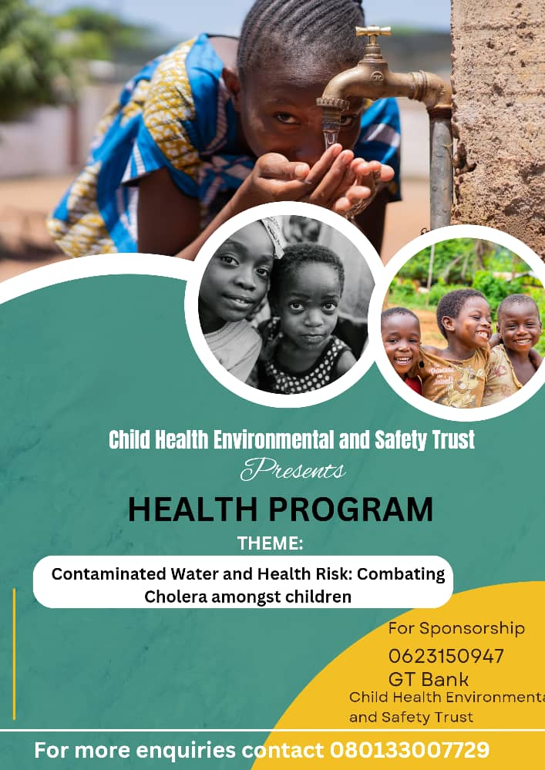

E-FLYER OF THE PROGRAMME
PHOTO SPEAKS
